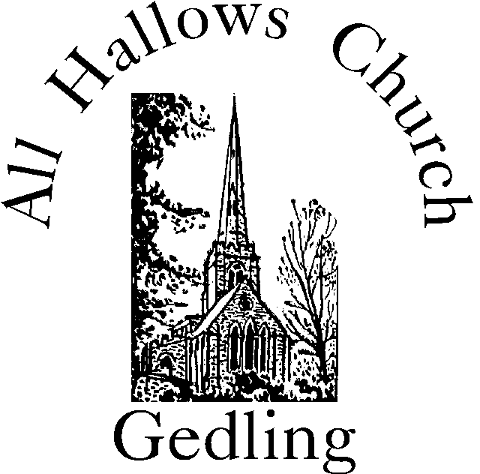

Terminology of the Church of England

& Job Descriptions

‘A guide to the workings of

All Hallows Church’

May 2022

Mission Statement
Worshipping God,
Sharing His word, Serving His world.
Contents:
Page 3 Diocese
Archdeaconry
Map of Diocese
Page 4 Archdeacon
Deanery
Map of Deanery
Page 5 Area Dean
Synod – General
Diocesan
Deanery
Deanery Rep
Page 6 Parish
Benefice
Incumbent – Rector
Vicar
Licensed Lay Minister
Page 7 Self-supporting Minister
Stipend
Giving for Ministry
Churchwarden
Page 8 Churchwarden
Page 9 Meeting of Parishioners
Annual Parochial Church Meeting (APCM)
The first PCC meeting of the year
Page 10 The Parochial Church Council (PCC)
Quinquennial Report
Page 11 Membership of PCC
Electoral Roll
Page 12 Electoral Roll Officer
Parish Safeguarding Officer
Page 13 DBS and safer recruitment
PCC Secretary
Page 14 Finance and Hon PCC Treasurer
Page 15 Building / Fabric Committee
Page 16 Faculty
Sidesperson
Server
Page 17 Intercessor
Verger
Page 18 Sexton
References
Terminology of the Church of England with job roles explained.

Diocese
A defined territory presided over by a bishop who may delegate to a suffragan bishop (in our case the Bishop of Sherwood)
Our Diocese is Southwell and Nottingham, the offices are in Southwell and the main church building for the Diocese is Southwell Minster Cathedral
Archdeaconry
A Diocese is divided into archdeaconries – we have Newark Archdeaconry and Nottingham Archdeaconry. They consist of rural deaneries. We are in Nottingham Archdeaconry
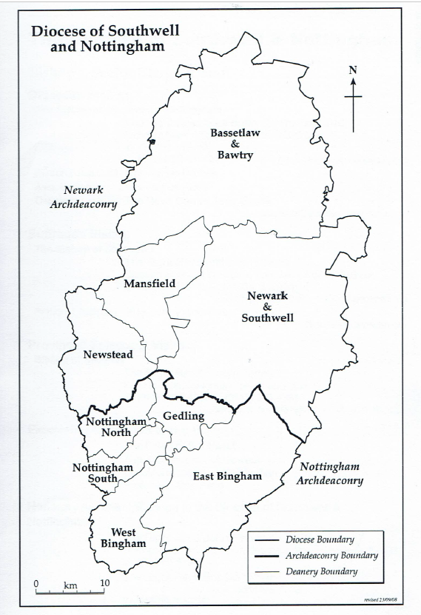
Archdeacon
Is appointed by the Bishop, has to have served at least six years in priest’s orders. An archdeacon has the power of visitation within the archdeaconry and it is at the archdeacons’ visitation after the end of April that churchwardens are admitted to office. Archdeacons also induct clergy by placing them in a benefice. Our Archdeacon is currently The Venerable Revd Phil Williams.
Deanery
Deaneries are units containing a number of parishes within an archdeaconry. Each deanery is presided over by an area dean who is usually a member of the clergy in that deanery.
Newark Archdeaconry has four Deaneries: Newstead; Mansfield; Bassetlaw & Bawtry; Newark & Southwell.
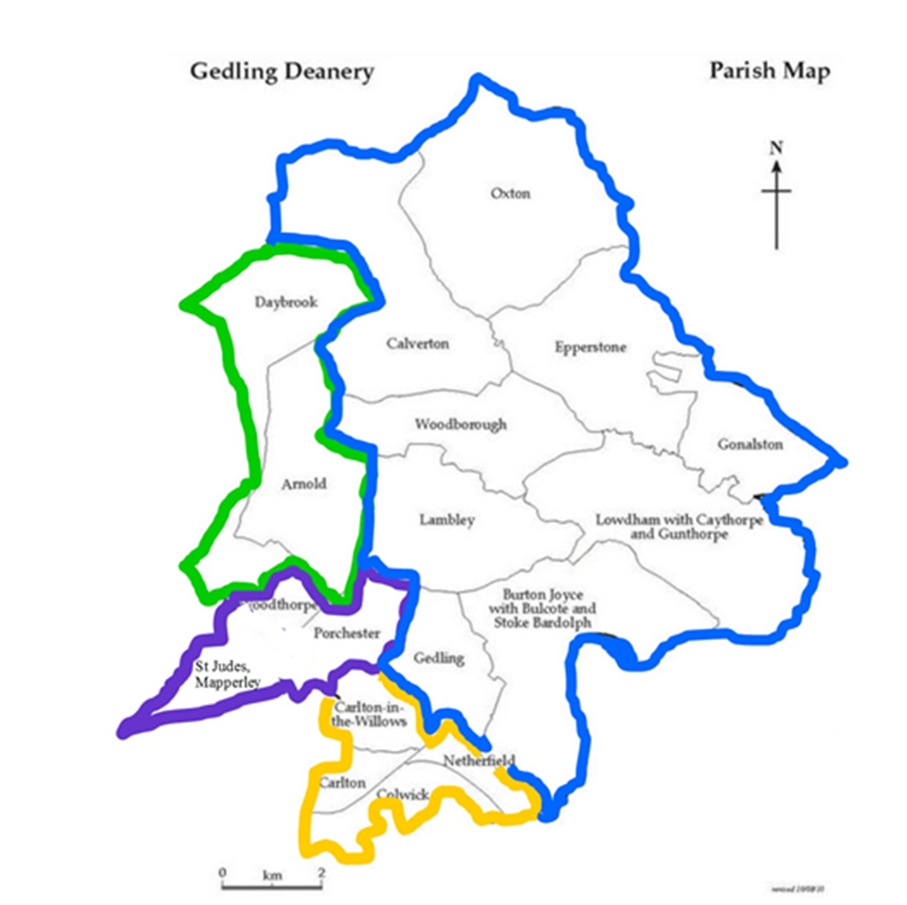
Nottingham Archdeaconry has five Deaneries: East Bingham; West Bingham; Nottingham North; Nottingham South and Gedling.
Area Dean
Our Area Dean is currently John Allister, Minister of St. Jude’s Mapperley
(A recent addition to the Deanery). The Area Dean reports on any matters required of the Archdeacon or Bishop and sits on the Diocesan Synod.

Synod
A synod is a Church Assembly containing a mixture of clerical and lay membership.
The General Synod is made up of the House of Laity (non clergy members) and the House of Clergy (Archdeacons and Canons) who debate upon matters of religious or public interest and makes legislations (Canon Law) and regulations.
Diocesan Synod is made up of three houses: a House of Bishops; a House of Clergy and a House of Laity. Its functions are to consider matters concerning the Church of England and to make provision for such matters in relation the diocese; express opinion on matters of religious or public interest; advise the bishop on any matters and express an opinion on any matters referred to it by the General Synod.
The Diocesan Synod keeps the deanery synods of the diocese informed of the policies and problems of the diocese and in turn is kept informed through the Deanery Synods of events and opinions in the parishes.
Deanery Synod consists of a House of Clergy and a House of Laity. It brings together views from the parishes in the deanery of any problems, reports on issues from the Diocesan synod. Each Deanery is allocated a certain amount of money it is to raise to pay the Diocese and the Deanery determines how much each Parish has to pay (quota). The Deanery Synod is chaired by the Area Dean

Deanery Rep
Each Parish is entitled to have a number of representatives from the Parish on the Deanery Synod, the number is dictated by the number on the electoral roll. All Hallows can have three electoral roll members as voted on at the APCM. They are automatically entitled to be on the PCC. All Hallows is represented by our Rector (House of Clergy) and currently Eleanor Wilson (House of Laity) we have two vacancies.
Parish
A Parish is an area committed to the incumbent (Rector/ Vicar) by the bishop for the cure (care) of souls. We are All Hallows Church in the Parish of Gedling. We are one of 18 parishes in the Gedling Deanery.

Benefice
The office of the rector or vicar of a Parish. The union of benefices is the concentration of both or all of the incumbencies of two or more parishes into the hands of one incumbent. The identity of the parishes themselves are not affected, remaining a separate parish, with its own parish church and parochial organisation. The link is the combined incumbencies become a single office held by a single incumbent whom they share. In our case All Hallows Gedling share an incumbent with Holy Trinity Lambley.

Incumbent
The smallest unit of organisation is the Parish. At the head of the Parish is the incumbent who is either a rector or a vicar. The titles go back to a time when rectors received a tithe (payment) from those living on the church land to maintain the minister and lived in a rectory. A vicar was employed by the monastery who took the tithe and provided a vicar to attend church duties who lived in a vicarage.

Licensed Lay Ministers
Lay refers to Laity which means a non-clergy person. Any person who is baptised and confirmed, a regular communicant of the Church of England, can be qualified to become a lay minister. To be a lay minister the candidate has to go through a lengthy process of interviews with various members of the clergy before being admitted onto a training course. On successful completion of a number of years training and examination of his or her knowledge and competence, the candidate obtains a Bishop’s certificate and is licensed to a parish.
A lay-minister’s function includes general pastoral work, officiating at Morning and Evening prayer (not absolution of sins), publication of Banns of Marriage, preaching and distributing holy communion (not consecrating the body and blood of Christ). A bishop can authorise a lay minister to conduct burial services at the invitation of the minister.

Self Supporting Minister A lay minister is usually a self supporting minister which means Non-stipendiary: Not paid, works voluntarily

Stipend Is a payment for work. The majority of clergy are Stipendiary but some are Self-supporting. Clergy are paid by the Diocese from funds raised by each Parish, known as Parish Share or Giving for Ministry.

Giving for Ministry
Each Parish is told how much money they have to raise to cover the cost of having an incumbent: the cost of their salary, housing, pension and training. The amount for each parish is decided by the Deanery which is responsible for making sure that all the parishes raise the money in order to pay the amount the Deanery is asked to raise by the Diocese. The amount depends on the number of incumbents and the comparative wealth of the Deanery. Currently All Hallows and Holy Trinity Lambley are asked to raise £84,000 as their quota for having one incumbent supporting them.

Churchwarden
The warden has a mixture of legal, spiritual and pastoral responsibilities as well as looking after the church and its contents. It is a role of leadership and sometimes needs courage, insight and the ability to stand up and speak up when necessary. It is vital to have the right people to be Churchwarden because so much depends on loyalty, leadership and hard work.
Each Warden signs a formal declaration of faith and diligence at the Visitation of the Bishop once a year. Wardens are representatives of the bishop in the parish. As a lay officer of the bishop, a churchwarden has the responsibility to report to the bishop if there is a major ‘neglect or default’ by the priest carrying out his duties.
Duties assigned to the wardens include:
Routine work: Churchwardens are not expected to do everything but to assign others to the work and organise things so that the Priest can be free to get on with the work of a priest.
Job Master: Churchwardens can help find the right person as a replacement for a specific job as and when necessary. This is done in consultation with the priest.
Getting to know people by name: It is customary for the wardens to have an unofficial pastoral role for the congregation. To greet someone by name, notice when they need extra support, to be a listening ear and to promote peace and unity where problems arise.
Worship: It is desirable for both wardens to be at the main service every Sunday morning and if possible Sunday evening too, along with the major church festivals. Churchwardens maintain order and decency in the church and churchyard especially during services.
Qualifications of the wardens: The two wardens must be baptised, be on the Church Electoral Roll, be actual communicants, aged over 21 years not disqualified under the Charities Act, not convicted for any offence against children. No person shall be chosen unless they have actually signified their consent to service in writing.
The length of service as a warden: is six successive years although a meeting of parishioners may decide by resolution that this does not apply in the parish.
Time for choosing the wardens: Two wardens are chosen annually by a Meeting of the Parishioners and not later than 30th April in the year. Candidates must be nominated and seconded in writing by people who are entitled to attend the Meeting of Parishioners. A nomination is not valid unless received by the Minister before the meeting.

The Meeting of Parishioners
The meeting is held annually following notice of a least two Sundays before the event. People entitled to attend are those on the Electoral Roll and those who are resident in the Parish.
The Chair is usually the Rector or if not present a chair is chosen by the meeting. The clerk is usually the PCC Secretary who takes the minutes.
The purpose of the Meeting of Parishioners is to appoint two churchwardens. If two candidates are presented they are automatically assigned the roll. If more that two candidates are presented there will be a vote of those present, cast at the meeting.
This meeting is immediately followed by
The Annual Parochial Church Meeting (APCM)
The meeting is held annually no later than 30th April each year and is preceded by the Meeting of Parishioners.
Who may attend: All Lay people whose names are entered on the electoral roll may attend and take part in proceedings. No other lay people are allowed to attend.
The purpose of the APCM is to accept the minutes of the previous APCM, to receive the Rector’s report, the Electoral Roll report, the Annual Report of the work of the PCC, the Financial statements and independently examined accounts and recommends the appointment of the independent examiner for the next year. The Annual Meeting also receives the Fabric Report, report on the Deanery, to elect Deanery representative every third year, to elect PCC members, to appoint sidespeople, to receive any other reports from working groups and other committees held by the church throughout the year.
This is followed by the First PCC meeting of the year.

The First PCC meeting of the year
The purpose of this meeting is to include the appointment or re-appointment of: Vice-chair of the PCC, Hon Secretary of the PCC, Hon Treasurer of the PCC, the Standing Committee, Electoral Roll Officer, any other agreed officers.
The Parochial Church Council (PCC)
The purpose of the PCC is to carry out a mixture of spiritual, legal, financial, pastoral and missionary functions.
The PCC shares the privileges and responsibility of making certain decisions with the Rector and in return it co-operates with the Rector on the whole mission of the church. The PCC has the right to be consulted on all matters of importance in the parish. The PCC and the Rector decide jointly how PCC money is to be used.
The PCC is responsible for maintaining and repairing all church buildings, the contents and the churchyard. All Hallows has a building committee which is involved with reporting to PCC both minor and major maintenance works that needs to be carried out.
The PCC has the right to receive the Quinquennial Report from the church architect. This is the inspection by the architect of the state of the building made every five years. PCC is responsible for carrying out the recommendations in the report under the direction of the church architect usually involving a faculty and fund raising.
The PCC is responsible for providing adequate insurance cover for paid and voluntary workers, for coach outings and public liability claims.
The PCC has the right to be consulted about the appointment of a new incumbent. The PCC appoints two representatives who interview the candidates who have been sent by the bishop. They have the right not to accept the first person put forward with a good reason or reasons for using their veto in this way.
The PCC has to be consulted on any major change that would affect the parish e.g. altering boundaries, group ministry, joined benefices. PCC has the right to meet the Archdeacon who is representative of any proposed changes.
The PCC acts in co-operation with the incumbent in promoting the parish, the whole mission of the Church, pastoral, evangelistic, social and ecumenical.
The PCC has responsibility under the Health and Safety Act, the Data Protection Act, Child Protection legislation (Safeguarding) and Charity Commissioners.
Membership of PCC
All Members of the PCC are Trustees of the Ecclesiastical Charity (Church of England All Hallows church) and as such have to be able to sign a declaration that they are not disqualified from being a charity trustee.
Ex-officio (by virtue of office): Rector; Clergy; Lay Ministers Licenced to the Parish, Churchwardens, Deanery reps.
Appointed officers: PCC Secretary, PCC Treasurer who may or may not be a member of the PCC. If not a member of PCC they would not have voting rights
Elected PCC members, the numbers depend on the size of the electoral roll. All Hallows is currently able to have 12 elected PCC members as our Electoral Roll has more than 100 names on it. PCC members must be on the electoral roll at the time of election.
Term of office: Elected members shall hold office for three years from election at the APCM. One third is appointed at the APCM, one third will retire after three years and one third will remain in office. i.e. All Hallows elects four PCC members each year as four members retire from office.
Where an elected member retires before the end of their term of office the casual vacancy may be filled for the remainder of that term of office.
The APCM may decide that a period of years should pass before re-election, or may decide that retiring members may be immediately re-elected. All Hallows has decided that a period of one year may pass before re-election, although that person could be co-opted for a year and then stand again for a further three years.
Quorum and agenda: No business shall be transacted at any meeting of the Council unless at least one-third of the members are present and no business be transacted which is not on the agenda except by the consent of three-quarters of the members present.
Electoral Roll
To be on the Electoral Roll a person must be baptised, 16 years of age or older, a member of the Parish church and living in the Parish, or not living in the Parish to have habitually attended worship for more than six months.
Electoral Roll Officer
Appointed at the first PCC meeting after the APCM. The duties are to keep the roll up to date by adding or removing names as necessary. To report on additions or deletions at the next PCC meeting.
Publish a list of all amendments to the Roll for 14 days before the APCM and to notify the Diocesan Synod the number of names on the electoral roll at the time of the APCM.
Removal of names if they have died; have been ordained; ask in writing to be removed; cease to live in the parish unless habitually attending the parish church; not a resident and have not habitually attended the church for the last six months; it was discovered they should not have been added in the first place.
Every sixth year a new electoral roll is prepared. All names are removed and PCC make reasonable steps to inform every person whose name is on the list that a new roll is being prepared. A new application form is required for every person whose name was on the previous roll. This should be completed and displayed between 14 days before the APCM during which time errors and omissions may be corrected. No new removals or additions can be made from this point until after the APCM.

Parish Safeguarding Officer (PSO)
The Diocese is committed to the safeguarding of everyone within the parishes and communities across the diocese. The Safeguarding Team provides advice on all safeguarding matters and upholds the national Church of England Safeguarding Principles, Policies and Practice Guidance. Each parish should appoint a Parish Safeguarding Officer (PSO) who is available to support members of the congregation locally, and work with the safeguarding team as required. PSO’s receive a national induction course and are appointed by the Rector working alongside the PCC. Parishes also appoint a lead recruiter to administer safer recruitment and DBS applications within the parish. This role is combined and currently Margaret Hicking is our PSO and lead recruiter.
The safeguarding team hold termly briefing sessions and once a year provides an invitation to a Safeguarding Event
DBS and Safer Recruitment
The Diocese of Southwell and Nottingham require DBS checks to be renewed every 3 years, these are currently completed by APCS. The Diocese will only accept DBS certificates completed by other agencies if they are registered with the DBS Updating Service.
There is an expectation that all clergy, readers, Church Wardens, and all PCC members and other Church Officers (paid or volunteers) who lead or help with children’s or adults’ activities, are DBS checked. The level of check will vary from a basic check to enhanced check depending on the role of the individual and their duties within the church.

PCC Secretary
The secretary is appointed at the first meeting after the APCM and is usually a member of the PCC but can be a co-opted member or a non-voting member. They should be aware of legalities of meetings and assist the chair during the meeting.
The secretary announces the next PCC meeting and sends a copy of an agenda to every PCC member along with any documents from committees, previous minutes, financial statement etc.
During the meeting to make careful notes of discussions and decisions, numbers voting for and against a resolution if the vote is close. Circulate an attendance register, to record and announce apologies, be aware of all matters which will arise from the minutes, consult with the chair before the meeting about any correspondence to be read out.
After the meeting prepare a draft copy of the minutes as soon as possible and submit them to the chair for approval. The minutes should be brief, accurate and adequate, a record of decisions made by PCC.
For the APCM the PCC secretary prepares the notice, agenda and various reports for the APCM, make available the necessary voting papers in good time. Take notes during the meeting and after the meeting put a notice up about the people on the new PCC and sends the Annual Report to the Diocese.

Finance and the Honorary PCC Treasurer
The Treasurer’s job is to look after the money, to report to the PCC on the financial situation and advise PCC on financial implications of any decision that it is about to make. A new PCC treasurer will be offered training provided by the Diocese and updated with any new charity rules and regulations.
Accrual accounts are kept with a statement of financial activities (SOFA) and balance sheet and notes to the end of the year, which are presented at the APCM. The PCC by law is required to account for all its funds which include Restricted – can only be used for a very specific purpose identified by the donor; Designated funds – money raised for a specific purpose but any unspent money is put towards other projects; Unrestricted funds – general funds used to pay everyday expenses of the church; Endowment funds – money given with the instruction that only income gained from it can be spent as in the case of stocks and shares.
The Annual accounts are prepared in January and arrangements made for accounts to be independently examined. The treasurer arranges the timetable with the priest or PCC, presents the accounts for discussion and open to questions. A resolution is put ‘that the PCC accepts the annual Accounts and Annual Report for presentation to the APCM’.
An Annual Budget is set using figures of income and expenditure from previous year to gauge the current year, planning how income may be allocated to expenditure. If there is a shortfall the PCC must decide the order of priority for paying bills after payment of urgent bills and instigate fund raising to cover costs if necessary. It is essential that the quota of Giving for Ministry is paid monthly by standing order and paid in full.
The Treasurer receives and pays in all money from collections keeping a register of them in the Register of Services. All income including planned giving, donations, fund raising, fees from weddings and funerals should be kept in the office safe until ready to be banked. Fees from weddings and funeral are paid to the various recipients. All payments should be made by online payment or cheque to ensure that an accurate record is kept of all transactions. At the end of each month a financial statement is made and checked against the bank statement and presented to PCC.
Every PCC has a charitable status and Gift Aid and GASDS (small cash gift aid scheme) can be reclaimed through the Inland Revenue on a quarterly basis. The treasurer must ensure that forms are filled in correctly and stored safely in the church office. An audit trail must be available to satisfy HMRC.
If no one is willing to take on the roll of treasurer it becomes the legal responsibility of the Churchwardens. No payment can be made for the work done by the treasurer.

Building Committee or Fabric Committee
All Hallows appoints a Building Committee who regularly inspects the building and calls upon the church architect when major work or the five yearly quinquennial report is carried out. The Building Committee reports to PCC and gives an annual report at the APCM.
The committee is given the power by the Churchwardens to carry out work which does not entail major changes or cost involved. Any work requiring payment is directed to the Finance Committee which in turn directs it for approval to PCC.
The Building Committee appoints professional people to carry out annual service checks e.g. Boiler service, fire extinguisher service, electrical checks. The committee carries out checks on the building to look out for leaks, to check all gutters, gulleys and drains. Arrange for a spring clean of church inside and out, clearing clutter, debris and weeds etc.
Inspects woodwork for signs of rot and infestation, check pipes for lagging and leakage, inspect plaster work for signs of rising damp.
Visually check the lightning conductor annually, check ventilators and extraction fans, check and look after boundary walls, fences and gates. All electrical wiring and lightning conductor should be checked every year and a written report should be kept on the church log book. Fires are sometimes caused by faulty wiring, particularly in the organ.
If work requires a faculty the building committee completes the online form.

Faculty
The buildings and lands situated within a diocese are under the guardianship of the bishop. If any alterations are required to be made to a consecrated building, its contents, churchyard or other consecrated burial ground, a legal proceeding has to be applied for – this is known as a Faculty.
The object of a Faculty is to ensure that the work proposed to be done maintains the integrity of the church building, property etc. All Hallows Church is a Listed Grade I building which also carries additional requirements through bodies outside diocesan control e.g. Heritage England and the Victorian Society etc.
Trivial additions include items that are not attached to anything and therefore can be easily removed. Trivial repairs may not require a faculty but work needs to be checked with the chancellor of the diocese who provides written guidance about what should or should not require a faculty. If any work requiring a faculty is carried out without approval of a faculty the work can be removed.

Sidesperson
Duties include arriving 20 minutes before the service to prepare service books and pewleaflets ready to hand to people as they arrive.
To greet and welcome people and show visitors where they might sit. To assist the Churchwardens in maintaining order and decency during the service.
To put service books away at the end and have a friendly word with those leaving.

Servers
One way to include young people in the church service is for them to become servers.
It is a great privilege to serve at the Eucharist (Holy Communion) and for this reason servers should do their utmost to make their part of the worship as perfect as possible. To be unobtrusive, movements carried out quietly, efficiently and with the minimum of fuss. Working with two servers requires harmony. Careful training is required.
Servers should arrive at least 20 minutes before the service to help with setting out all the items necessary to conduct the Eucharist. Light candles, check everything is in place for the officiating minister. Assist the minister as required, the duties will be learnt during the training process.
At the end of the service, snuff out candles (never blow them out), help clear away items used for the Eucharist and respectfully put everything back in its place.

Intercessors
Each week at the 9.30am Sunday service, members of the congregation who are on the rota read out the prayers they have written for that particular week. The prayers are basically organised into prayers for the world, for the country, for the church, for the parish, for the church community, for the sick, for the deceased, for the self. There might be a theme taken from the bible readings, reference to recent events that have happened or about to happen. Training can be given to help with composing intercessions. Currently Linda Freeman organises the rota and can help with more information.

Vergers
The post of verger is a self-employed paid job for assisting at weddings and funeral services. The verger arrives in good time to prepare church for the service, to set up cones to keep the layby free and to sweep the porch and path. The verger makes sure there are enough chairs available, reserve seats as necessary, receive the orders of service and hand them out as people arrive. Keep a record of how many people attend and make sure that all visitors are welcomed and looked after. Any collection taken should be recorded and the money stored in the safe. The verger is responsible for health and safety of visitors and security for the church building at all times during and after the service. The verger is responsible for ensuring that the church is fully secured upon leaving the building, that all candles have been extinguished and everything returned to its original position.
Sexton
The post of a sexton is a self-employed paid job for assisting, organising and preparing plots for the interment of ashes. Funeral directors/family members liaise with the sexton about dates and times when the interment might take place. The sexton contacts a member of the clergy to confirm dates and time. Records are kept of the name of the interred and the plot number which corresponds to a plan of the area of the Gardens of Rest in the churchyard. The sexton prepares the plot in advance, supports the family and fills in the interment site. Forms are completed by the funeral directors/family members outlining size and type of wording of the plaques. The sexton checks that this satisfies the All Hallows rules and regulations from the Garden of Rest policy.

Policy Documents

Can be found at www.allhallowsgedling.co.uk / About / Documents

Safeguarding; Health & Safety; Data Protection; Fire evacuation procedures.

Also PCC minutes, APCM reports, Year end accounts can be found on the website: / About / All Hallows PCC documents

Reference Books
A Handbook for Churchwardens and parochial Church Councillors (2001 Edition)
Kenneth M Macmorran and Timothy Briden

The Church of England Directory Diocese of Southwell & Nottingham 2010

An ABC for the PCC A Handbook for Church Council Members John Pitchford 2003

https://southwell.anglican.org/resources/resources-safeguarding/dbs-and-safer-recruitment/ 2022

Disclaimer – this guide was put together by Eleanor Wilson in good faith. 18.05.22

